EXPERIMENT 2

PART B

|  |  |
| --- | --- |
| Roll No. C009 | Name: Samarth Borade |
| Class : BTI SEM 10 | Batch : EB1 |
| Date of Experiment: 22/12/23 | Date of Submission: 22/12/23 |
| Grade : |  |

**B.1 Software Code written by student:**

# Samarth Borade

# BTI SEM 10

# C009

# EXP 2

# Aim: Implementing Multilayer Perceptron



# Modules used for data handling and linear algebra operations.

import pandas as pd

import numpy as np

# Modules used for data visualization.

import matplotlib.pyplot as plt

import seaborn as sns

sns.set_style()

# Modules used for preprocessing

from sklearn.preprocessing import OneHotEncoder

# Modules used for Machine Learning models.

from sklearn.linear_model import Perceptron

from sklearn.neural_network import MLPClassifier

# Modules used for hyperparameter tuning.

from sklearn.model_selection import GridSearchCV

from sklearn.model_selection import RandomizedSearchCV

# Models used for evaluating the model.

from sklearn import metrics

from sklearn.model_selection import cross_val_score

# Suppressing the warnings.

import warnings

warnings.filterwarnings('ignore')

**Dataset 1:**

df = pd.read_csv("crx.csv", header=None)

headers = df.iloc[0]

df  = pd.DataFrame(df.values[1:], columns=headers)

cat_cols = []

num_cols = []

for i in df.columns:

    if df[i].dtype == "O":

        cat_cols.append(i)

    else:

        num_cols.append(i)

null_freq = []

for i in df.columns:

    f = dict(df[i].value_counts())

    if "?" in f.keys():

        null_freq.append(f["?"]*100/len(df))

    else:

        null_freq.append(0)

pd.Series(dict(zip(df.columns,null_freq))).plot(kind="bar",

                                                rot=0,

                                                title="Missing Value Frequency",

                                                xlabel="Column Name",

                                                ylabel="Percentage of missing values",

                                                color=["orange","crimson"])

plt.show()

df['a16'].value_counts().plot(kind="bar",

                           title="Class Distribution",

                           xlabel="Status of Credit Card Approval",

                           ylabel="Frequency of the Status",

                           color=["crimson","orange"],

                           rot=0)

plt.show()

df = df.replace({"?":None})

df = df.dropna()

encoder = OneHotEncoder(sparse=False)

for i in cat_cols:

    df[i] = encoder.fit_transform(df[i].values.reshape(-1,1))

from sklearn.model_selection import train_test_split

X_train,X_test,y_train,y_test = train_test_split(df,

    df['a16'],

    test_size = 0.30,

    train_size=0.70,

    random_state = 0

)

X_train.pop('a16')

X_test.pop('a16')



clf = Perceptron(random_state=0)

clf = Perceptron(random_state=0)

y_pred_train = clf.predict(X_train)

y_pred_test = clf.predict(X_test)

df.dtypes.value_counts().plot(kind="bar",

                              title="Types of Data",

                              xlabel="Data Type",

                              ylabel="No.of columns",

                              rot=0,

                              color=["crimson","orange"])

plt.show()

clf = MLPClassifier(random_state=1, max_iter=300).fit(X_train, y_train)

y_pred_train = clf.predict(X_train)

y_pred_test = clf.predict(X_test)

metrics.accuracy_score(y_true=y_train,y_pred=y_pred_train)

metrics.accuracy_score(y_true=y_test,y_pred=y_pred_test)

**Dataset 2:**

df = pd.read_csv("cirrhosis.csv", header=None)

headers = df.iloc[0]

df  = pd.DataFrame(df.values[1:], columns=headers)

**B.2 Input and Output:**

**Input:**

**Dataset 1:**

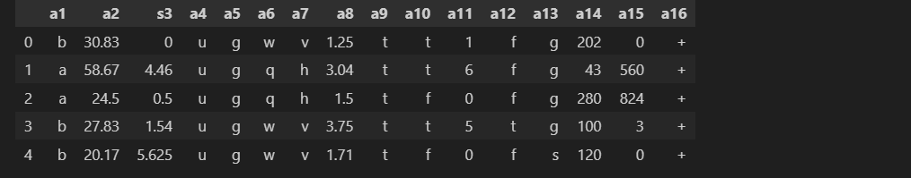

<class 'pandas.core.frame.DataFrame'>

RangeIndex: 690 entries, 0 to 689

Data columns (total 16 columns):

# Column Non-Null Count Dtype

--- ------ -------------- -----

0 a1 690 non-null object

1 a2 690 non-null object

2 s3 690 non-null object

3 a4 690 non-null object

4 a5 690 non-null object

5 a6 690 non-null object

6 a7 690 non-null object

7 a8 690 non-null object

8 a9 690 non-null object

9 a10 690 non-null object

10 a11 690 non-null object

11 a12 690 non-null object

12 a13 690 non-null object

13 a14 690 non-null object

14 a15 690 non-null object

15 a16 690 non-null object

dtypes: object(16)

memory usage: 86.4+ KB

**Dataset 2:**

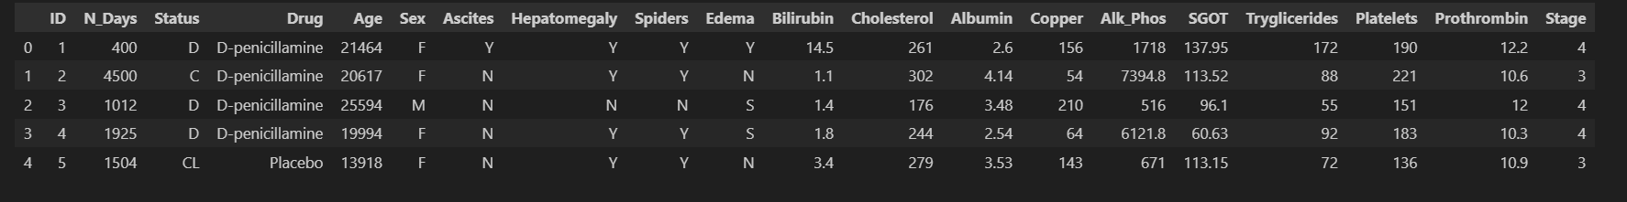

<class 'pandas.core.frame.DataFrame'>

RangeIndex: 418 entries, 0 to 417

Data columns (total 20 columns):

# Column Non-Null Count Dtype

--- ------ -------------- -----

0 ID 418 non-null object

1 N_Days 418 non-null object

2 Status 418 non-null object

3 Drug 312 non-null object

4 Age 418 non-null object

5 Sex 418 non-null object

6 Ascites 312 non-null object

7 Hepatomegaly 312 non-null object

8 Spiders 312 non-null object

9 Edema 418 non-null object

10 Bilirubin 418 non-null object

11 Cholesterol 284 non-null object

12 Albumin 418 non-null object

13 Copper 310 non-null object

14 Alk_Phos 312 non-null object

15 SGOT 312 non-null object

16 Tryglicerides 282 non-null object

17 Platelets 407 non-null object

18 Prothrombin 416 non-null object

19 Stage 412 non-null object

dtypes: object(20)

memory usage: 65.4+ KB

**Output:**

**Dataset 1:**

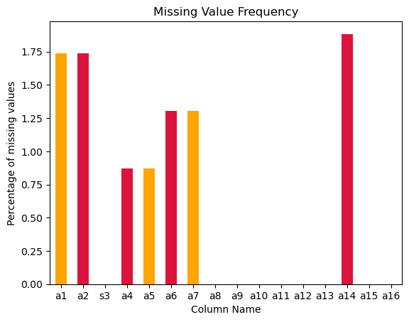

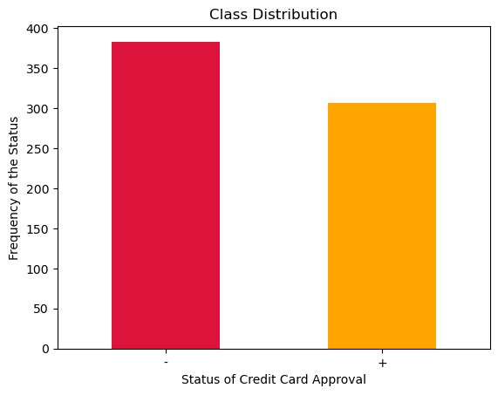

**Perceptron:**

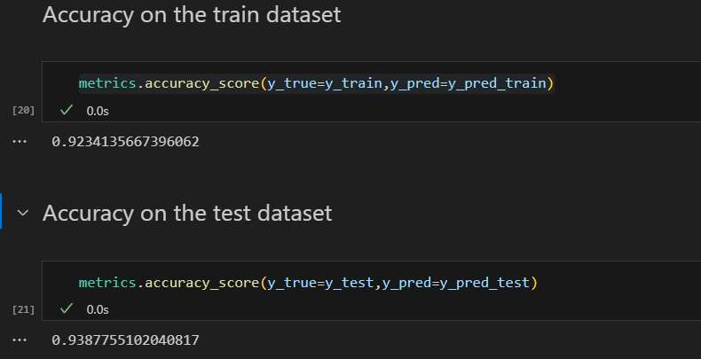

**Multilayer Perceptron:**

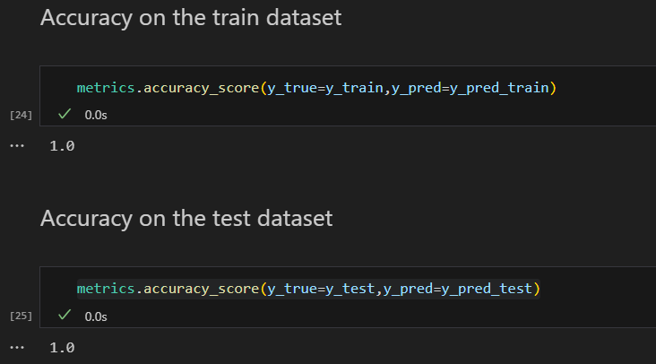

**Dataset 2:**

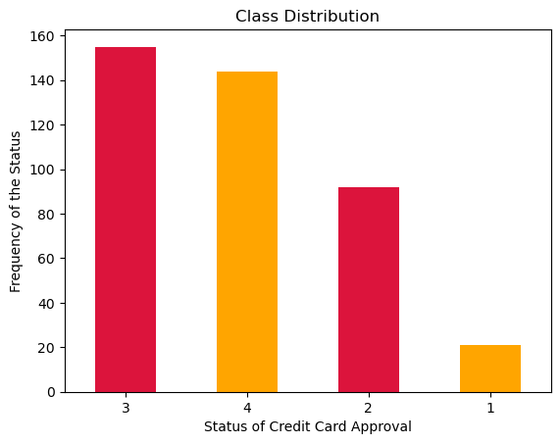

**Perceptron:**

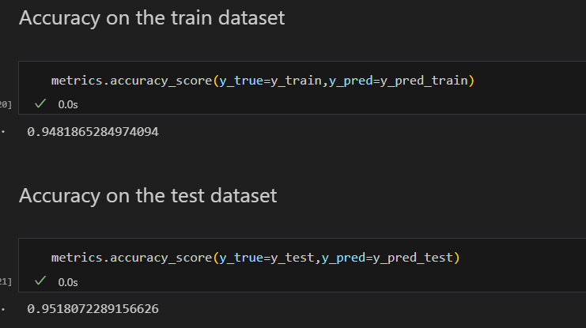

**Multilayer Perceptron:**

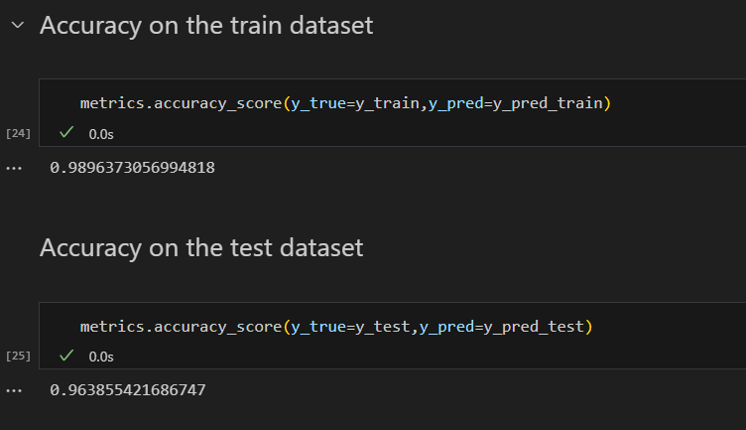

**B.3 Observations and learning:**

For Multilayer perceptron: **10 hidden layers**

clf = MLPClassifier(hidden_layer_sizes=(10), max_iter=300,activation = 'relu',solver='adam',random_state=1).fit(X_train, y_train)

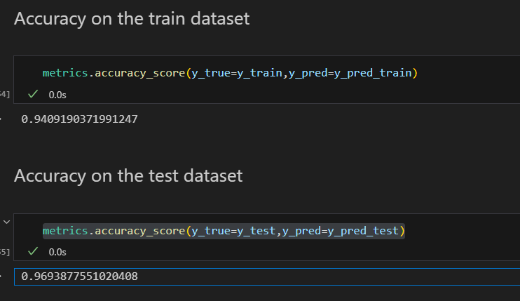

**For 100 hidden layers:**

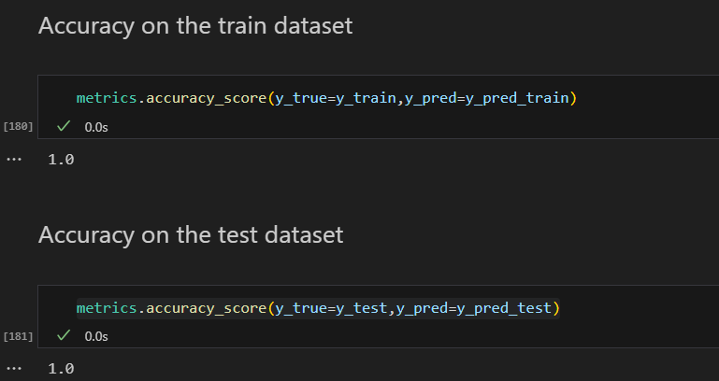

We observed increase in the accuracy after increasing the hidden layers. I even added few more parameters:

**hidden_layer_sizes*array-like of shape(n_layers - 2,), default=(100,)***

The ith element represents the number of neurons in the ith hidden layer.

**activation*{‘identity’, ‘logistic’, ‘tanh’, ‘relu’}, default=’relu’***

Activation function for the hidden layer.

* ‘identity’, no-op activation, useful to implement linear bottleneck, returns f(x) = x
* ‘logistic’, the logistic sigmoid function, returns f(x) = 1 / (1 + exp(-x)).
* ‘tanh’, the hyperbolic tan function, returns f(x) = tanh(x).
* ‘relu’, the rectified linear unit function, returns f(x) = max(0, x)

**solver*{‘lbfgs’, ‘sgd’, ‘adam’}, default=’adam’***

The solver for weight optimization.

* ‘lbfgs’ is an optimizer in the family of quasi-Newton methods.
* ‘sgd’ refers to stochastic gradient descent.
* ‘adam’ refers to a stochastic gradient-based optimizer proposed by Kingma, Diederik, and Jimmy Ba

**B.4 Conclusion:**

Multilayer Perceptron gives us more parameters to play on the dataset and for better scalability also better accuracy as per increasing epochs/hidden layers . Successfully implemented perceptron and multilayer perceptron on the new dataset “cirrhosis.csv” classifying stages of cancer.

**\*\*\*\*\*\*\*\*\*\*\*\*\*\*\*\*\*\*\*\*\*\*\*\*\*\*\*\*\*\*\*\***